**Create a Setup so that you can ping google but not able to ping Facebook from same system**

We use “nslookup” command to **get the ip address** of [www.google.com](http://www.google.com)

Ip of google we got was: **172.217.166.36**

**Command:** “nslookup [www.google.com](http://www.google.com)”

**And tried to ping it was working**

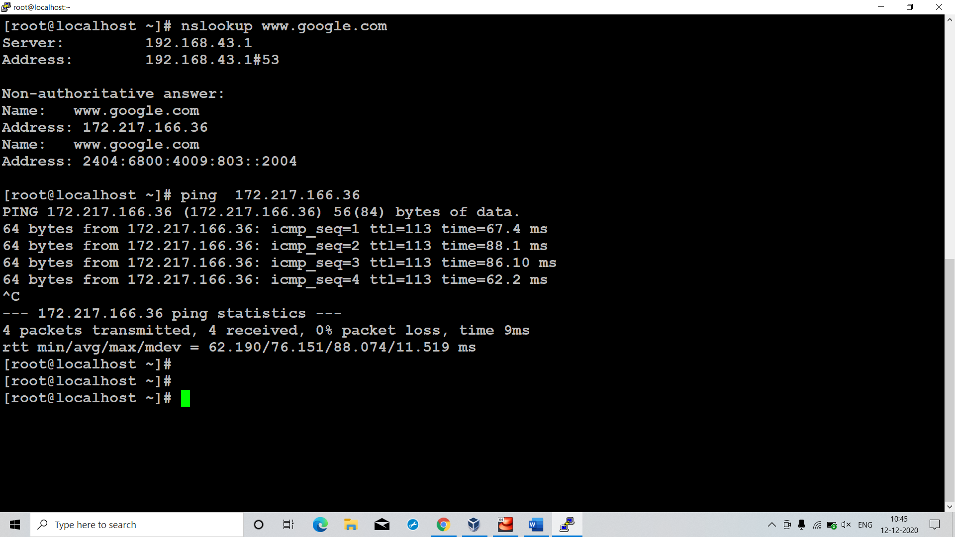

Again we use “nslookup” command to **get the ip address** of [www.facebook.com](http://www.facebook.com)

Ip of facebook we got was: **69.171.250.35**

**Command:** “nslookup www.facebook.com”

**And tried to ping it was working**

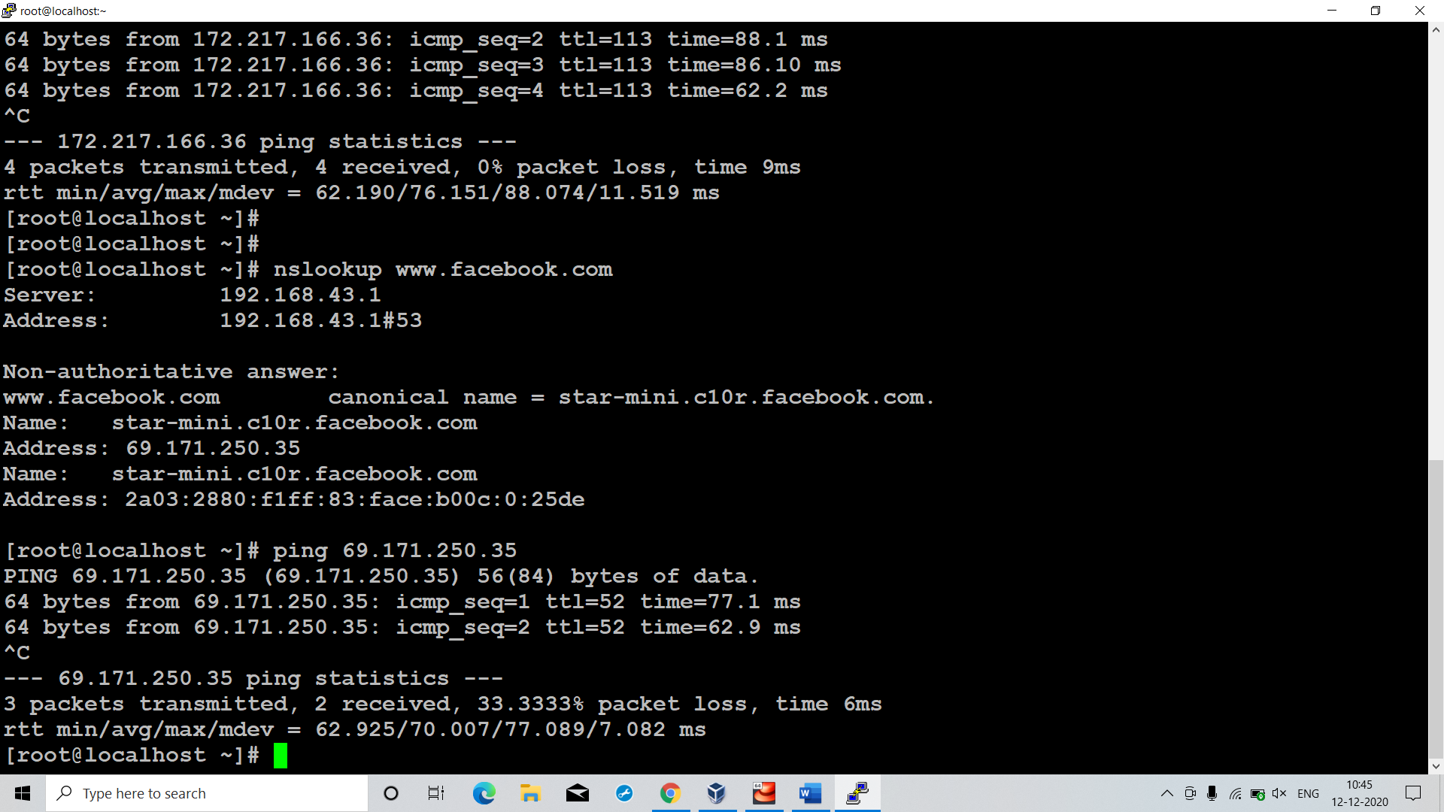

Then we **deleted default gateway** from routing table i.e. destination=0.0.0.0 and genmask=0.0.0.0

And added a rule such that our system can create packets only for particular network/range and that network was of google. In that rule **destination=172.217.166.0** and **genmask=255.255.255.0**

**Command:** route add -net 172.217.166.0 netmask 255.255.255.0 gw 192.168.43.1 enp0s3

Hence our system can create n/w packets for **172.217.166.36** but not for any ip which is not in this network.

If we notice **facebook ip(69.171.250.35)** is not in the above network hence our system can’t create n/w packets for it

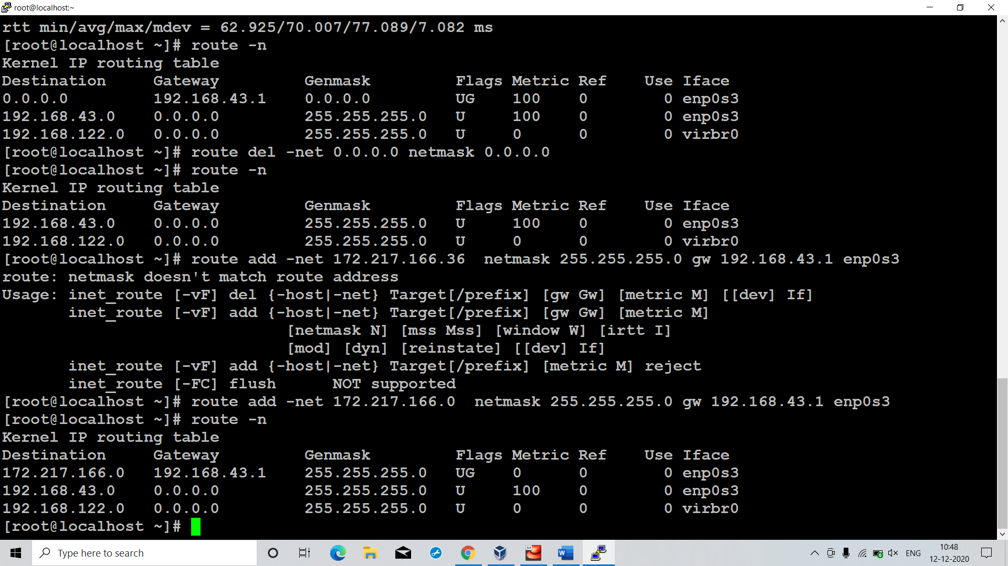

Hence now we can see that our system **can ping to google ip** but **can’t facebook ip!!!!!!**

